**JIRA ACCOUNT CREATION**

On google browser type, ***try Jira***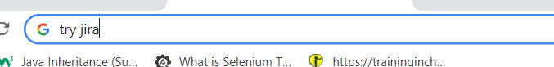

Select: Free-Jira software

Redirects to below page – Select ***Next*** here (Right bottom)

On giving Next, Choose an account to Continue – Preferably Google

The below page loads, post selecting email address. Hit on Create your account

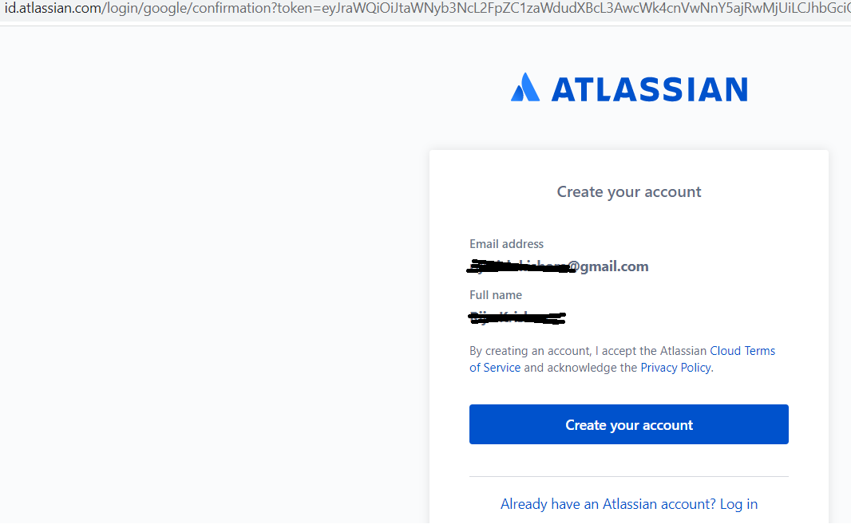

**Give project name and hit on Continue**

On giving continue, the below page appears. Hit on skip

Next page: Add registered email address if you want someone under Assignee or Assigned.

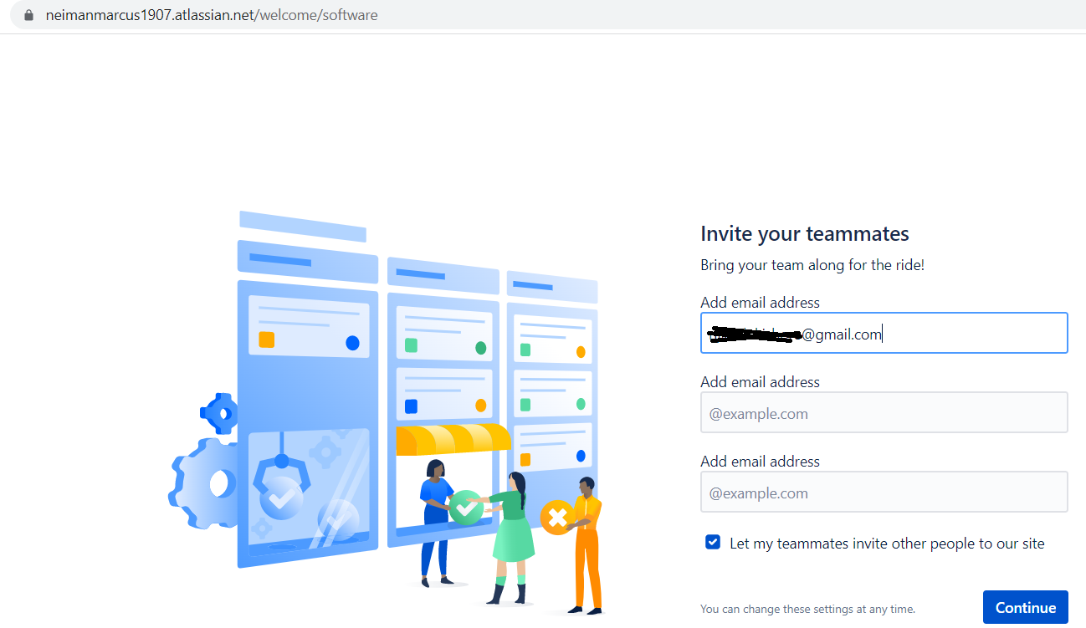

**Hit on skip:**

On giving skip gets redirected to the below page. **Select “Bug Tracking”**

**Add project details:** Start by entering the Project Name and hit Create Project

**HOW TO REPORT BUG IN JIRA**

Click Create. Hit three dots on top right corner and show fields, select required fields.

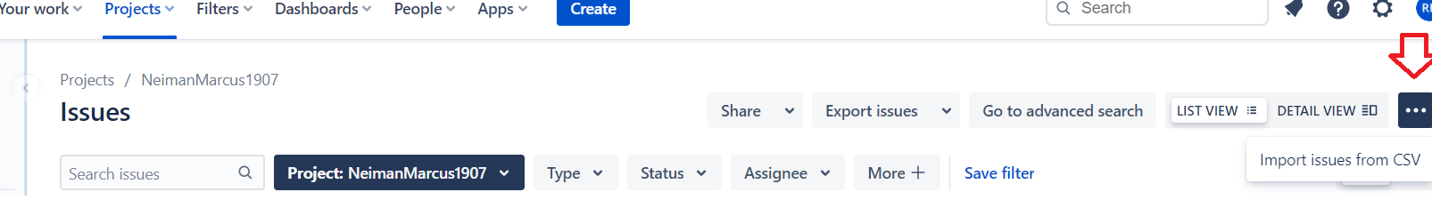

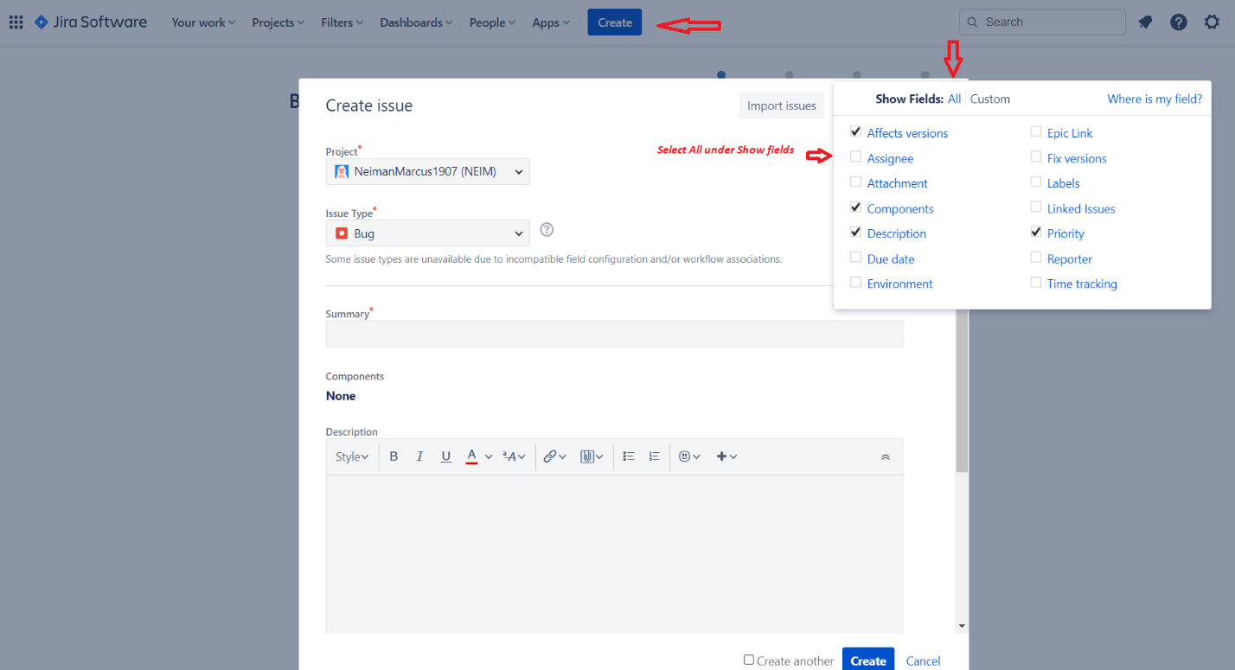

**Fill in Summary, description… Hit create**

Hit on Create.

**How to search on bugs created:**

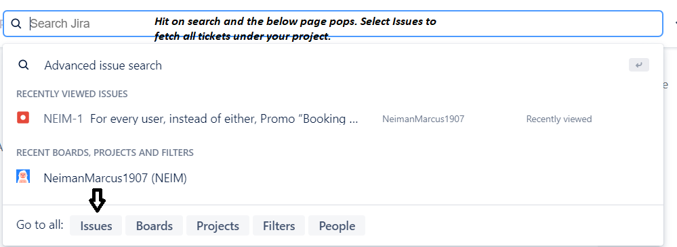

**BUG STATUS, ASSIGNMENT AND PRIORITY**

Choose ToDo to change the bug status. Click on Unassigned adjacent to Assignee to assign to a particular induvial, select priority and severity according to impact and how soon the bug must be resolved.

